Name:B.Arun H.No:2303A51735 Batch:25
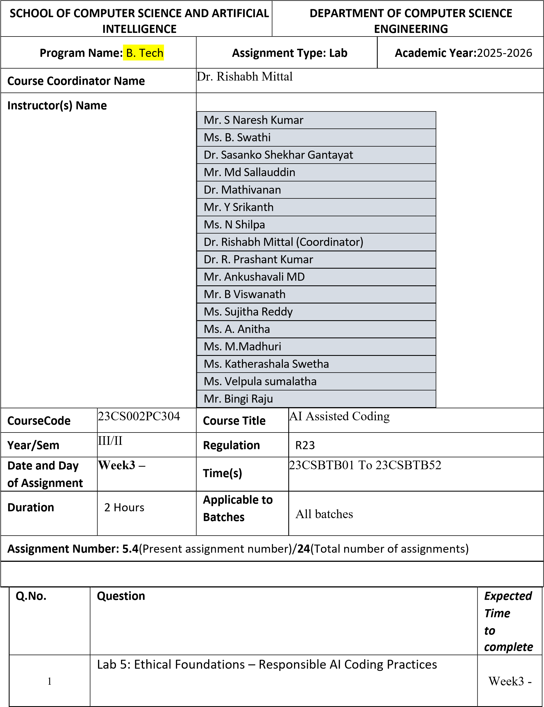

Lab Objectives:
- To explore the ethical risks associated with AI-generated code.
- To recognize issues related to security, bias, transparency, and copyright.
- To reflect on the responsibilities of developers when using AI tools in software development.
- To promote awareness of best practices for responsible and ethical AI coding.
Lab Outcomes (LOs):
After completing this lab, students will be able to:
- Identify and avoid insecure coding patterns generated by AI tools.
- Detect and analyze potential bias or discriminatory logic in AI-generated outputs.
- Evaluate originality and licensing concerns in reused AIgenerated code.
- Understand the importance of explainability and transparency in AI-assisted programming.
- Reflect on accountability and the human role in ethical AI coding practices.
Task Description #1:
- Prompt GitHub Copilot to generate a Python script that collects user data (e.g., name, age, email). Then, ask Copilot to add comments on how to anonymize or protect this data.
Expected Output #1:
- A script with inline Copilot-suggested code and comments explaining how to safeguard or anonymize user information (e.g.,

hashing emails, not storing data unencrypted).
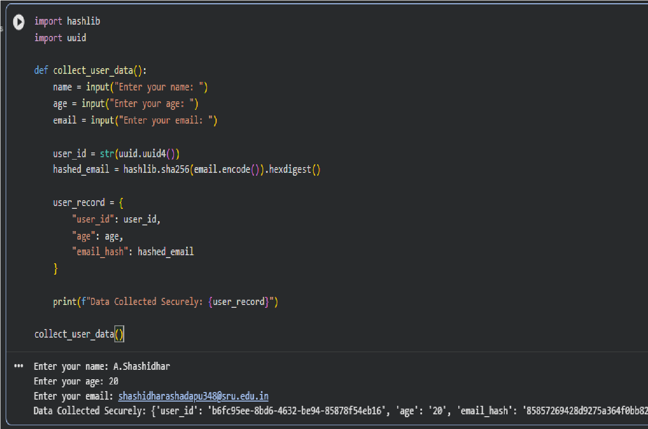
Task Description #2:
- Ask Copilot to generate a Python function for sentiment analysis. Then prompt Copilot to identify and handle potential biases in the data.
Expected Output #2:
- Copilot-generated code with additions or comments addressing bias mitigation strategies (e.g., balancing dataset, removing offensive terms).

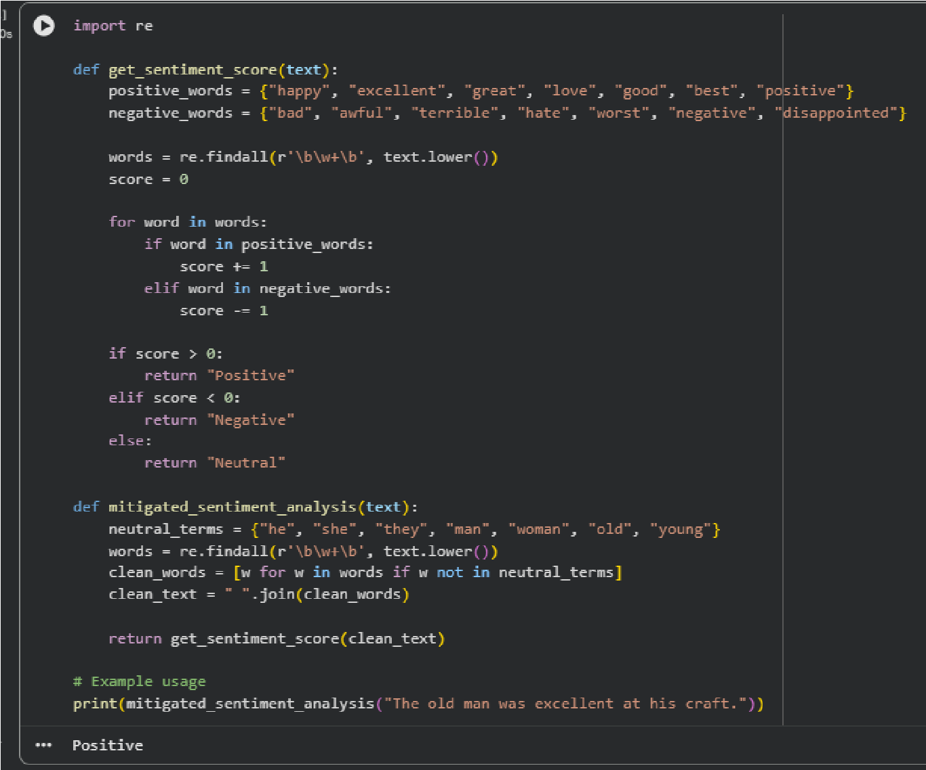
Task Description #3:
- Use Copilot to write a Python program that recommends products based on user history. Ask it to follow ethical guidelines like transparency and fairness.
Expected Output #3:
- Copilot suggestions that include explanations, fairness checks
(e.g., avoiding favoritism), and user feedback options in the code.

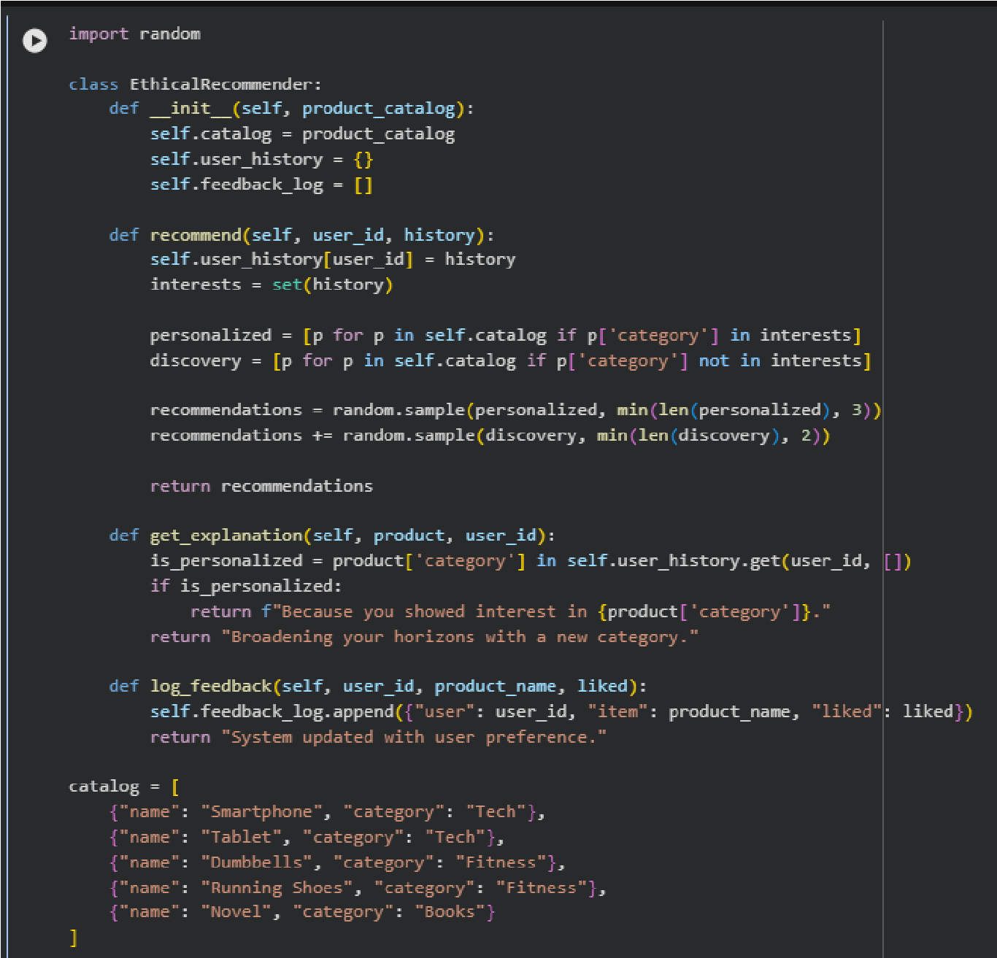
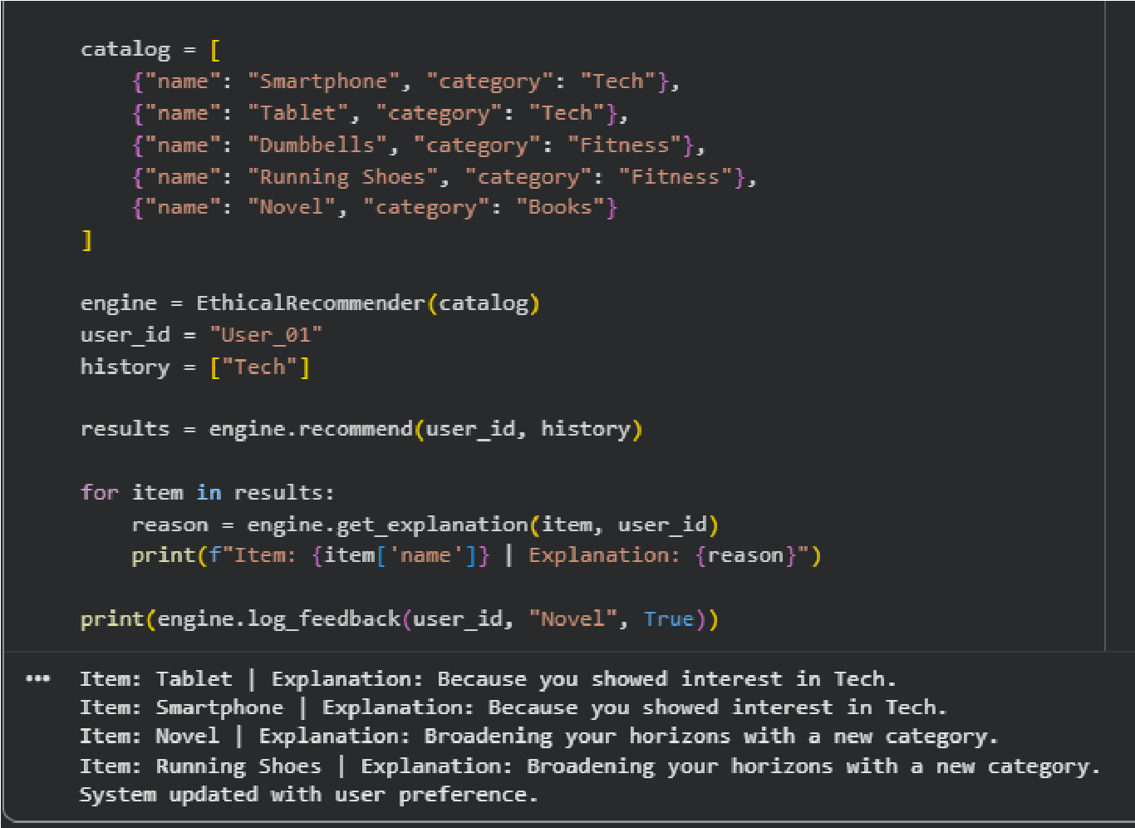
Task Description #4:
• Prompt Copilot to generate logging functionality in a Python web application. Then, ask it to ensure the logs do not record sensitive

information.
Expected Output #4:
- Logging code that avoids saving personal identifiers (e.g., passwords, emails), and includes comments about ethical logging practices.
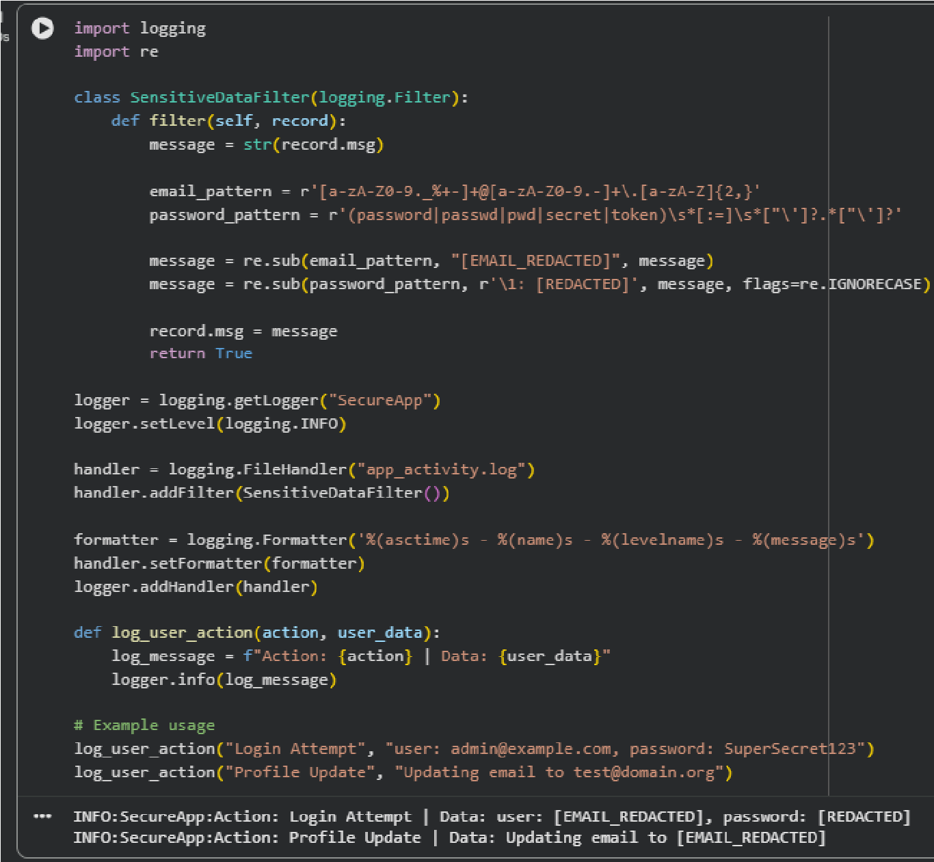
Task Description #5:
- Ask Copilot to generate a machine learning model. Then, prompt it to add documentation on how to use the model responsibly (e.g., explainability, accuracy limits).
Expected Output #5:
- Copilot-generated model code with a README or inline documentation suggesting responsible usage, limitations, and fairness considerations.
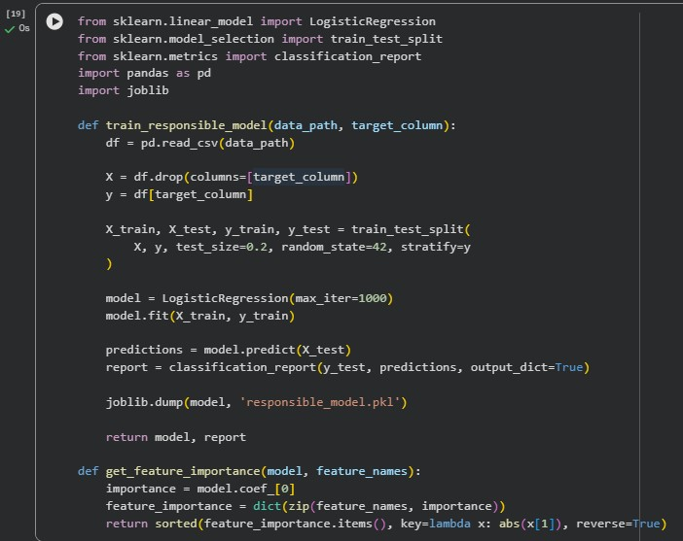

Note: Report should be submitted a word document for all tasks in a single document with prompts, comments & code explanation, and output and if required, screenshots

